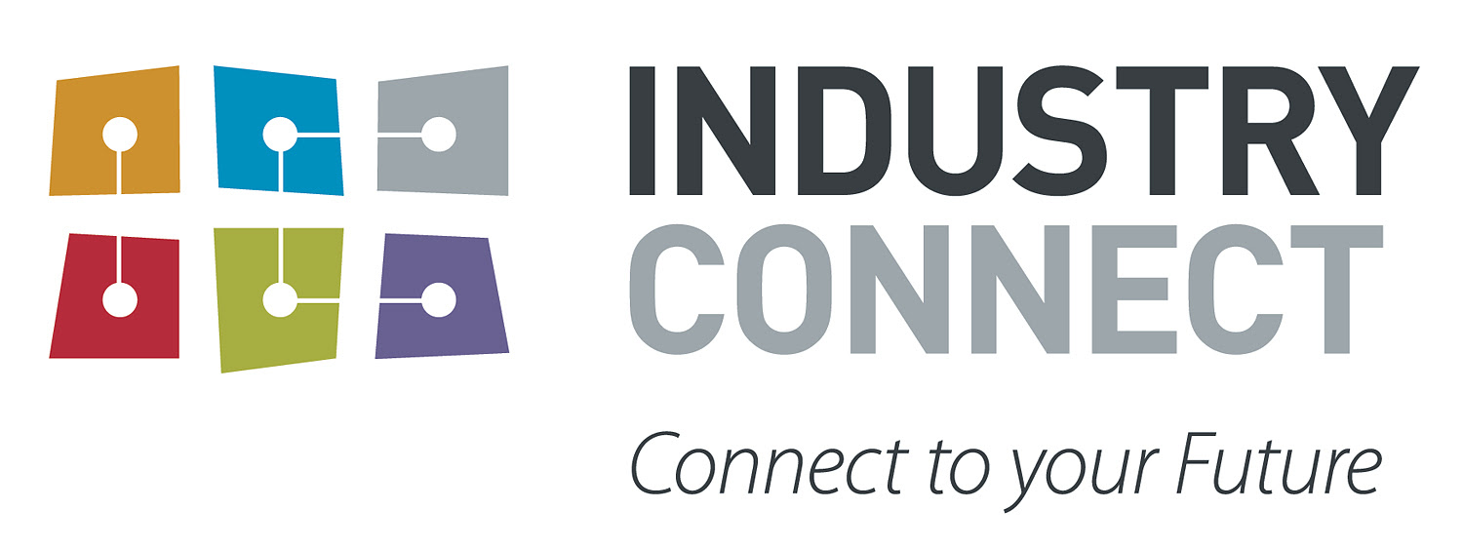

**Participant Onboarding**

# **Welcome to Industry Connect**

We are super excited to have you on board.

Industry Connect (IC) aims to make participants job-ready by the end of the programme, therefore we would like to make sure you will utilise the best of our online / on-site resources.

We know how difficult it is for the first time onboard, this documentation will ease the process and get familiar with our existing infrastructure.

# **Training Material**

All IC tutors and participants use Industry Connect Portal to access our training material please visit <http://industryconnect.io> and use the username and password you received in your email to login.

If you are **unable** to log in using the password that you received via email, please try resetting your password at the link below:  
<http://www.industryconnect.io/Authentication/ForgetPassword>

You can access the training material from the Programme Menu or from the Calendar. <http://industryconnect.io/Course/Home/MyProgram>

# **Question Hub**

Question Hub is Industry Connect internal Q & A platform (similar to Stack Overflow). Participants can access Question Hub via <http://industryconnect.io> It’s the best resource for you to learn.

All general questions have been asked on Question Hub, so please spend some time to look through the questions and answers before asking a new question.

# **Communication**

Industry Connect uses Slack ([download here](https://slack.com/downloads/)) as our main communication tool for our participants.

You will receive an invitation to the Industry Connect Slack channel.

If you need to send/receive messages to the group or an individual, please use Slack.

# **Internship**

After 6 weeks of video training and Workshops, an internship will be arranged for you with one of our commercial projects from MVP Studio. The internship is run remotely, either part-time or full-time. Depending on your interest and flexibility, you can choose which project to do the internship (Please note, sometimes there could only be one project available to join).

*How to join the internship:*

You will receive an email with the link on how to join the Internship in Week 5. In the video we will explain the internship procedures, project details and technology used..

# **CV Preparation and Interview Simulation**

Prior to starting to apply for jobs our Team at *MVP Studio* and the Team at *GTIO* will review your CV to ensure that it is up to market standards, and give feedback on changes to make.

When you are successful in obtaining a job interview it’s important to inform the MVP Studio Team so that they can arrange a mock interview with you as it will help you to be well prepared before going to the real interview.